AWS Security Incident Response — Detection Capabilities and Supported Use Cases
Nov 8, 2026 · @Lumi O
AWS Security Incident Response (AWS SIR) is now onboarded across all AWS accounts and performs first-line triage on GuardDuty and integrated security findings, escalating only validated incidents to our IR team. This page records what detection coverage the service provides, which use cases it supports, how that coverage maps to the Microsoft Sentinel CloudTrail analytic rules we disabled, and which gaps remain in Sentinel.

Background and decision
The Sentinel-side AWS detection set produced a high proportion of false and benign positives, and the alert volume was consuming SOC and IR analyst time without a matching gain in detection coverage. Three problems drove the change.
- Low precision. The CloudTrail-based custom analytic rules and the built-in AWS S3 solution rules fired on activity that was authorised and routine. Each alert still required an analyst to confirm that, so the cost of a benign positive was the same as the cost of a true positive.
- Narrow coverage. Detection logic was anchored to CloudTrail management-plane events and to a small set of resource types. Activity on EC2, EKS, Lambda, RDS, ECS and S3 data-plane paths was either not covered or only covered indirectly, so the rules did not generalise as the AWS estate grew.
- Tuning cost. Reducing the false-positive rate required per-account, per-principal exclusion logic maintained by our team in KQL. That work does not scale across the account estate and the exclusions themselves become a detection gap over time.

What changed
AWS Security Incident Response (AWS SIR) is now enabled across all AWS accounts through AWS Organizations, with the monitoring, investigation and proactive response features turned on. AWS performs first-line triage and escalates to our IR team only where activity cannot be confirmed as expected. Most CloudTrail-based Sentinel analytic rules were disabled as part of the same change.
CloudTrail, GuardDuty and WAF log ingestion into Sentinel continues. The logs remain available for hunting, investigation, correlation with non-AWS telemetry, and compliance retention — only the alerting logic on top of the CloudTrail stream was retired.

How AWS SIR works
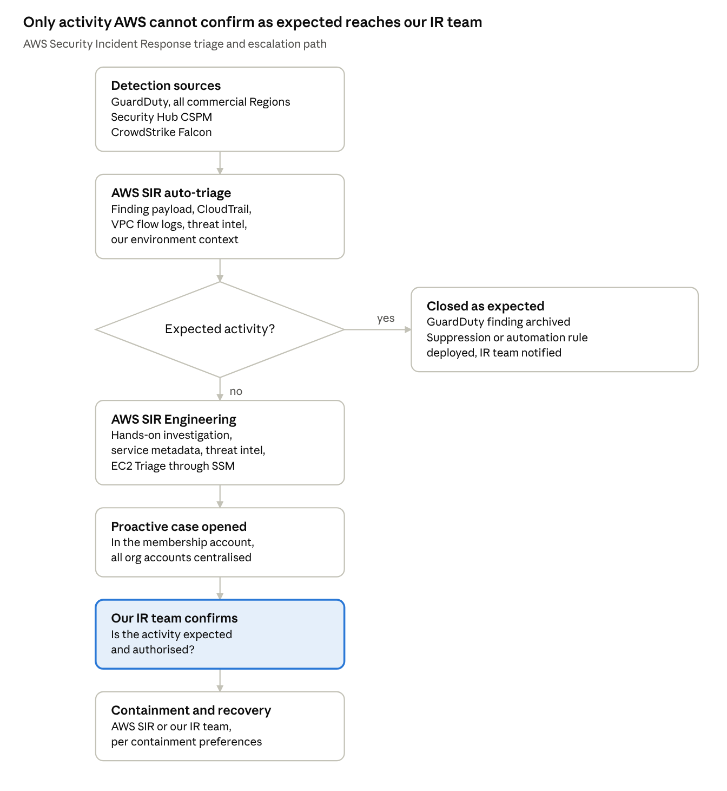
AWS SIR triage and escalation · 7 steps, 1 decision
Findings reach AWS SIR through EventBridge rules deployed into our accounts at onboarding. Automated triage resolves the large majority without human involvement; only findings it cannot confirm as expected reach AWS SIR Engineering, and only a subset of those reach us as a proactive case. The decision point in the middle is where the alert-fatigue problem is absorbed — by AWS, against AWS telemetry, rather than by our analysts against KQL exclusions.

Detection sources
AWS SIR is not a detection service. It generates no findings of its own and does not replace GuardDuty, Security Hub CSPM or any third-party detection tool — it ingests findings from detection sources already in place and triages them on our behalf (AWS SIR User Guide). Detection coverage is therefore exactly the coverage of the upstream sources we enable; AWS SIR determines what happens to a finding after it is raised, not whether it is raised.
Source | Status in our estate | What it contributes | Reaches AWS SIR
Amazon GuardDuty | Enabled, all accounts | Threat findings across IAM/CloudTrail, VPC DNS and flow logs, S3 data events, EKS audit logs, EC2 runtime, RDS login activity, Lambda network activity, and malware scanning | Yes — primary source
AWS Security Hub CSPM | Enabled | Aggregation point for AWS service findings and third-party detections | Yes — threat findings only
CrowdStrike Falcon | Deployed | Endpoint and workload detections on EC2 | Yes, once integrated through Security Hub CSPM
Trend Micro Cloud One, Fortinet Lacework FortiCNAPP | Not in use | Named third-party integrations AWS SIR supports | Supported, not applicable here
AWS CloudTrail, VPC Flow Logs | Enabled, ingested to Sentinel | Used by AWS SIR as investigative context during triage, not as a detection trigger | Not as a finding source
AWS WAF logs | Ingested to Sentinel | Web request and rule-match telemetry | No — see Retained Sentinel coverage

Two distinctions that matter for coverage
CloudTrail is context, not a trigger. Automated triage analyses the finding payload, AWS service metadata, AWS logging and monitoring data such as CloudTrail and VPC Flow Logs, AWS threat intelligence, and context we provide about our environment (Detect and Analyze). CloudTrail is read to decide whether a GuardDuty finding is expected. A CloudTrail event that produces no GuardDuty or Security Hub finding produces no AWS SIR activity. This is the single most important consequence of disabling the Sentinel CloudTrail rules and is covered in the mapping section.
Posture findings are out of scope. AWS SIR does not triage security posture findings — compliance and configuration findings are informational by nature and do not require threat investigation. CSPM, config drift and control failures remain ours to manage through Security Hub CSPM standards and our own governance process.

Regional scope
With the monitoring and investigation feature enabled, AWS SIR monitors GuardDuty findings from all active commercial AWS Regions, and where the service is not enabled in a Region, alerts are not available for that Region. GuardDuty must therefore stay enabled in all supported Regions, including Regions we do not actively deploy into, so that activity in unused Regions is still detected.

Supported use cases
The use cases below are those AWS SIR triages and investigates end to end. Each one is a threat scenario raised by GuardDuty or by a Security Hub CSPM-integrated tool; AWS SIR adds the triage, investigation and escalation layer on top. Coverage spans identity, network, compute, container, serverless, storage and database resource types — the breadth the Sentinel CloudTrail rules did not reach.
Use case | Example detection signals | Resource scope
Credential compromise and misuse | Anomalous IAM principal behaviour; API calls from known-malicious IPs, Tor exit nodes or unusual ASNs; anomalous console or CLI usage patterns | IAM users, IAM roles, root account, federated identities
Instance credential exfiltration | EC2 instance role credentials used from outside AWS, or from a different AWS account than the instance | EC2, ECS, EKS node roles
Privilege escalation | Anomalous policy attachment, role assumption chains, trust policy modification, permission boundary changes | IAM, STS
Persistence and backdoor establishment | New IAM user or access key creation by an anomalous principal, backdoored resources, unauthorised identity provider changes | IAM, Organizations, IdP configuration
Defence evasion | CloudTrail trail disabled, deleted or reconfigured; logging suppression; GuardDuty detector tampering; security tooling disabled | CloudTrail, GuardDuty, Config
Reconnaissance and discovery | Anomalous enumeration of accounts, roles, buckets, secrets or instances; port probes against unprotected ports | IAM, S3, Secrets Manager, EC2
Command and control | Outbound DNS or network connections to known C2 infrastructure, DGA domains, or threat-intel-listed hosts | EC2, EKS, ECS, Lambda
Cryptomining and resource hijacking | Bitcoin or mining-pool traffic, anomalous instance launches, anomalous spend patterns correlated with compute activity | EC2, ECS, EKS, Lambda
Data exfiltration | Anomalous S3 object retrieval volume or pattern; DNS-tunnelling exfiltration; data transfer to anomalous destinations | S3, EC2, RDS
S3 data-plane abuse | Anomalous read, write or delete behaviour on buckets; public access block disabled; object-level anomalies | S3
Malware on compute and in storage | Malware found by GuardDuty Malware Protection scans on EBS volumes and on newly uploaded S3 objects | EC2, EBS, S3
Runtime compromise | New or suspicious binary execution, process injection, container escape, reverse shell, filesystem tampering | EC2, ECS on Fargate, EKS (Runtime Monitoring)
Kubernetes threats | Anonymous access granted, privileged container launched, exec into kube-system pods, anomalous API server calls | EKS
Database credential attacks | Anomalous successful logins, brute-force patterns, logins from malicious IPs | RDS (Aurora, MySQL, PostgreSQL)
Serverless compromise | Anomalous Lambda network activity, C2 callbacks from function execution environments | Lambda
Ransomware and destructive impact | Mass deletion or encryption behaviour, snapshot deletion, KMS key disablement or scheduled deletion | S3, EBS, RDS, KMS
Endpoint and workload detections | CrowdStrike Falcon detections surfaced through Security Hub CSPM | EC2 instances with the Falcon sensor
Customer-raised security events | Any event our team raises directly in the AWS SIR portal, including suspected incidents with no corresponding finding | Any AWS resource

Response capabilities attached to these use cases
Triage is not the end of the service. Three capabilities apply once a case is open.
- AWS SIR Engineering engagement. A global, always-available team of AWS security professionals takes the investigation when automated triage cannot confirm activity as expected, and responds to a case within minutes.
- EC2 Triage. With the Containment with EC2 Triage CloudFormation template deployed, AWS SIR responders can run Systems Manager Run Command against an instance to collect investigative data, inspect running processes and analyse system state without direct instance access. Supported on Amazon Linux 2 and 2023, Ubuntu 18.04 to 24.04, RHEL 7–9, CentOS 7–8, SLES 12–15, Debian 10–12, and Windows Server 2012 R2 through 2022. The instance must have SSM Agent running and be managed by Systems Manager.
- Containment actions. Subject to the containment preferences we set, AWS SIR can perform containment on our behalf rather than only advising on it.

Feedback loop
Where triage concludes that activity is authorised, AWS SIR deploys a GuardDuty suppression rule or a Security Hub CSPM automation rule matching the finding type and source — IP address, ASN, identity principal or resource. Security Hub CSPM rules are deployed at priority 10 so our own rules can override them. Our IR team is notified of every rule-set change and can have any of them rolled back on request. This is the mechanism that replaces the manual KQL exclusion work described in the background section.

Coverage mapping against the retired Sentinel rules
The retired rules fall into three groups. Threat-shaped detections — malicious infrastructure, anomalous principal behaviour, logging tamper, mass data operations — are met or bettered by GuardDuty plus AWS SIR triage. Anomaly-adjacent detections are covered probabilistically rather than deterministically: GuardDuty fires on deviation from a learned baseline, so a single authorised-looking API call that our KQL rule caught every time may not raise a finding. Deterministic configuration and posture detections are not covered at all, because AWS SIR explicitly does not triage posture findings.
Set the coverage value in the table as each row is verified against our own disabled-rule inventory.
Detection intent (retired in Sentinel) | AWS SIR / GuardDuty equivalent | Coverage
Root account credential usage | GuardDuty root credential usage finding, auto-triaged | Covered
CloudTrail trail disabled, deleted or reconfigured | GuardDuty CloudTrail logging disabled, defence-evasion family | Covered
GuardDuty detector or security tooling disabled | GuardDuty defence-evasion findings on detector tampering | Covered
API activity from malicious IPs, Tor or anomalous geography | GuardDuty malicious-IP-caller and anomalous-behaviour findings with AWS threat intelligence | Covered
Activity in unused or unexpected Regions | GuardDuty enabled in all commercial Regions, monitored by AWS SIR | Covered
Mass S3 download, deletion or encryption | GuardDuty S3 exfiltration and impact anomaly findings | Covered
IAM policy modification and privilege escalation | GuardDuty privilege-escalation anomalous behaviour — anomaly-based, not every policy change | Partial
New IAM user, access key or login profile created | GuardDuty persistence anomalous behaviour — fires on anomalous principals only | Partial
Console login brute force and failed-auth bursts | GuardDuty unauthorised-access findings — threshold and baseline driven | Partial
Secrets Manager and Parameter Store enumeration | GuardDuty discovery anomalous behaviour | Partial
KMS key disablement or scheduled deletion | GuardDuty impact anomalous behaviour — no deterministic finding type | Partial
Organizations, SCP and account-level configuration change | Partial anomaly coverage; no dedicated finding type | Partial
Console or API login without MFA | Posture finding in Security Hub CSPM — explicitly not triaged by AWS SIR | Gap
Security group or NACL opened to 0.0.0.0/0 | Posture finding in Security Hub CSPM — not triaged | Gap
S3 bucket policy or public access configuration change | Posture finding — retained in GuardDuty without archiving, no threat investigation | Gap
EBS snapshot or AMI shared to an external account | No equivalent finding type in GuardDuty | Gap

What the Gap rows require
Each Gap row is a deterministic configuration-change detection. None of them should be rebuilt as a Sentinel CloudTrail analytic rule, because that reintroduces the false-positive problem. Three options, in order of preference:
- Preventive control. Enforce through SCP, AWS Config conformance packs or IaC policy-as-code so the change cannot be made rather than detected after the fact. Applies to public S3 access, open security groups and external snapshot sharing.
- Posture pipeline. Route the Security Hub CSPM control failure to the governance and remediation queue, not the SOC alert queue. This matches the existing Prisma Cloud remediation workflow rather than SIEM alerting.
- Low-volume Sentinel rule, scoped tightly. Only where neither of the above fits, and only scoped to production accounts and high-value resources, with the expected daily volume agreed with the SOC before the rule is enabled.

Retained Sentinel coverage and residual gaps
AWS SIR does not make Sentinel redundant for AWS. Four categories of detection and analysis stay with us, and two of them have no AWS-side equivalent at all.

AWS WAF — no AWS SIR coverage
WAF logs are not a detection source for AWS SIR. GuardDuty does not consume them and Security Hub CSPM does not carry WAF rule-match findings as threat detections. The WAF analytic rules on response codes and rate-limit breaches therefore remain the only detection on that telemetry, and they stay enabled. Their false-positive profile is a separate tuning problem from the CloudTrail rules and should be worked on its own:
- Scope rules to specific production sites and resource ARNs rather than all WAF-enabled distributions.
- Alert on sustained rate-limit breaches and blocked-request bursts from a single source, not on individual rule matches.
- Use WAF logs for enrichment on AWS SIR cases involving internet-facing EC2 or ALB resources.

Cross-cloud and cross-domain correlation
AWS SIR sees AWS. It does not see Entra ID, Microsoft 365, on-premises Active Directory, CrowdStrike telemetry outside the Security Hub CSPM integration, or the Azure estate. Any attack chain that crosses from AWS into the Microsoft estate — or arrives in AWS from a compromised corporate identity — is only visible in Sentinel. Correlation rules spanning AWS CloudTrail and Entra ID sign-in logs stay enabled and are the highest-value remaining use of the AWS logs in Sentinel.

Hunting, investigation and compliance
CloudTrail, GuardDuty and WAF ingestion continues. The logs support threat hunting, post-incident investigation, correlation during an AWS SIR case, and the retention requirements our audit and compliance obligations impose. Disabling alerting logic did not change ingestion scope or retention.

Posture and configuration findings
AWS SIR triages no posture findings. CSPM results, control failures and configuration drift continue to flow through Security Hub CSPM into the existing remediation process. This is governance work, not SOC alerting, and should not be routed back into the Sentinel incident queue.

The residual risk to accept explicitly
Anomaly-based detection has a different failure mode from deterministic rules. A deterministic rule misses nothing in its scope and alerts on everything, including benign activity. An anomaly-based detector alerts on far less but can miss an attacker whose actions resemble the learned baseline — a compromised credential used during business hours, from an expected Region, performing API calls the principal normally performs. GuardDuty plus AWS SIR triage is the better trade for our volume, but low-and-slow identity abuse by a well-informed attacker is the scenario where the retired rules performed better. Cross-domain correlation in Sentinel is the compensating control, and the ingestion we have retained is what makes it possible.

Operating model
AWS SIR is an organization-level service hosted in a designated membership account, which centralises case communication for every account in the organization. Cases AWS SIR opens carry the [Proactive case] prefix; cases we open ourselves do not.
Activity | Owner | Notes
Generate findings | GuardDuty, Security Hub CSPM, CrowdStrike | AWS SIR generates none
First-line triage of threat findings | AWS SIR automation | Expected activity closes with no further action
Security investigation where triage is inconclusive | AWS SIR Engineering | Hands-on analysis of service metadata, threat intelligence and prior findings in our environment
Confirm whether activity is expected and authorised | Our IR team | Requested through the case; response latency directly affects time to resolution
Containment execution | AWS SIR Engineering or our IR team | Depends on the containment preferences configured
Detection tuning in GuardDuty and Security Hub CSPM | AWS SIR, with notification to us | Rolled back on request
WAF detection and tuning | Our detection engineering team | No AWS SIR coverage
Cross-domain correlation and hunting | Our SOC in Sentinel | AWS SIR has no visibility outside AWS
Posture and configuration remediation | Our cloud governance process | Out of AWS SIR scope by design
Raising a suspected incident with no finding | Our IR team, through the AWS SIR portal | Does not require a preceding finding

Case handling expectations
Two things determine whether this model performs better than the one it replaced.
The first is response latency on our side. A proactive case is open because AWS SIR could not determine from telemetry alone whether the activity was authorised. Only we can answer that. A slow answer extends the investigation and, where the activity was in fact malicious, extends attacker dwell time. A named on-call rotation for AWS SIR cases, with a defined acknowledgement target, is the control here.
The second is environment context quality. Triage accuracy improves with the context we supply about our AWS and on-premises environments: which principals perform automated work, which IP ranges and ASNs are ours, which Regions are in use, which behaviour is expected for which workload. Every proactive case we resolve as benign should produce a context update, not just a case closure. That is the mechanism by which the false-positive rate falls over time rather than staying where it was.

Integration with our existing tooling
AWS SIR case creation emits events to Amazon EventBridge. That is the integration point for routing cases into our incident management and notification path — ServiceNow, Teams, or a Sentinel incident created from the case — so that AWS SIR cases land in the same queue as everything else rather than only in the AWS console. Confirm whether this is already wired up; if not, it is the highest-value remaining onboarding task.

Open questions and actions
- ☐ Reconcile the coverage table against the actual inventory of disabled Sentinel analytic rules and set each coverage value
- ☐ Confirm GuardDuty protection plans enabled per account: S3 Protection, EKS Protection, Runtime Monitoring, Malware Protection for EC2 and for S3, RDS Protection, Lambda Protection
- ☐ Confirm GuardDuty is enabled in all commercial Regions, including unused ones
- ☐ Confirm whether the CrowdStrike Falcon integration into Security Hub CSPM is configured, so Falcon detections reach AWS SIR triage
- ☐ Deploy the Containment with EC2 Triage CloudFormation StackSet and verify SSM Agent coverage across the EC2 fleet
- ☐ Define and document containment preferences: which actions AWS SIR may take unilaterally versus advise on
- ☐ Wire AWS SIR case creation through EventBridge into the incident management and on-call notification path
- ☐ Define the on-call rotation and acknowledgement target for proactive cases
- ☐ Agree the process for reviewing AWS SIR-deployed suppression and automation rules, and the trigger for rolling one back
- ☐ Decide the treatment for each Gap row: preventive control, posture pipeline, or scoped Sentinel rule
- ☐ Re-tune the WAF analytic rules independently of this change
- ☐ Establish the metric set for the next review: proactive cases per month, benign rate, mean time to our confirmation, and incidents found by AWS SIR that the retired rules would have missed

Sources
- What is AWS Security Incident Response? — service boundaries, case types, regional scope
- Detect and Analyze — AWS Security Incident Response User Guide — detection sources, automated triage, EC2 Triage, finding updates, service tuning
- AWS Security Incident Response features — supported third-party integrations, EventBridge integration
- Optimize security operations with AWS Security Incident Response — configuration and operating guidance
GuardDuty finding families in the use-case table are described generically rather than by exact finding type string, since the type list changes with each protection plan release. Verify current finding types against the GuardDuty finding types reference before using this page as a control-mapping artefact.

